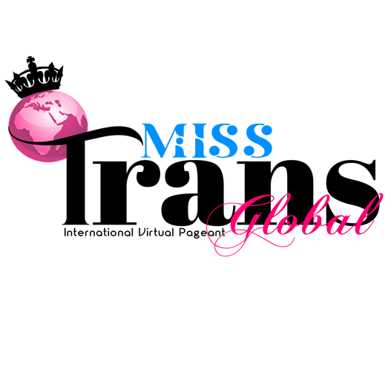
FOR IMMEDIATE RELEASE

MISS TRANS GLOBAL PAGEANT 2020
An International digital pageant raising awareness for transgender women

LONDON, UK — Miss Trans Global is an inaugural event providing a platform for a diverse heritage of transgender women from all works of life. The pageant’s key goal is to raise awareness and funds for vulnerable transgender women. In 2020, our focus is on trans women suffering in isolation due to the Covid-19 pandemic.

2020’s edition includes participants from Australia, Nigeria, Philippines, South Africa, Sweden, United States of America, Uruguay and so many more.

The contestants are set creative challenges every week in a bid to showcase their charisma and talent. The organisation’s definition of a queen is someone who is a voice for the voiceless and marries the ambition of helping a marginalised community that is often discriminated against and persecuted due to misconceptions.

According to the organisation’s founder Miss saHHara,

“Miss Trans Global was conceived in 2017 but realised during isolation in 2020. Our communities around the world are often either stuck at home with transphobic family members, or homeless due to family rejection. Many of us are misunderstood at home and marginalised in society. Also, we have limited earning opportunities. So, we decided to help address some of these issues by engaging our online global community through the Miss Trans Global Digital Pageant”.

The winner of Miss Trans Global will be a spokesperson on transgender issues and work tirelessly to influence positive changes in our communities. She will work closely with activist organisations such as TransValid, TransBeauty Magazine and many more allies to raise money, educate the mainstream society and inspire transgender people globally.

ABOUT MISS TRANSGLOBAL:
Miss Trans Global is an international digital event held to bring transgender women from all backgrounds together to showcase their abundant talents, wits, creativity and raise awareness on transgender issues worldwide.
###

If you would like more information about Miss Trans Global, please contact:

Contact: Sally Adams
Email: press@misstransglobal.com
Website: www.MissTransGlobal.com
Social Media: https://www.facebook.com/MissTransGlobal
https://twitter.com/MissTransGlobal
https://www.instagram.com/misstransglobal
https://www.youtube.com/misstransglobal

If you are still worried about a correctly written press release - you can ask for help from specialists.

